Vibe coding brings AI collaboration to everyday software teams
Krishna Padam IT Solution is introducing “Vibe Coding,” an AI-guided approach to software development that reshapes how engineers interact with code. Instead of writing every line manually, developers collaborate with intelligent assistants to explore ideas, draft features, and refine solutions. The concept reflects a broader industry movement toward AI-assisted development, where platforms such as GitHub and OpenAI help shorten delivery cycles and make professional-grade software creation accessible to more teams.

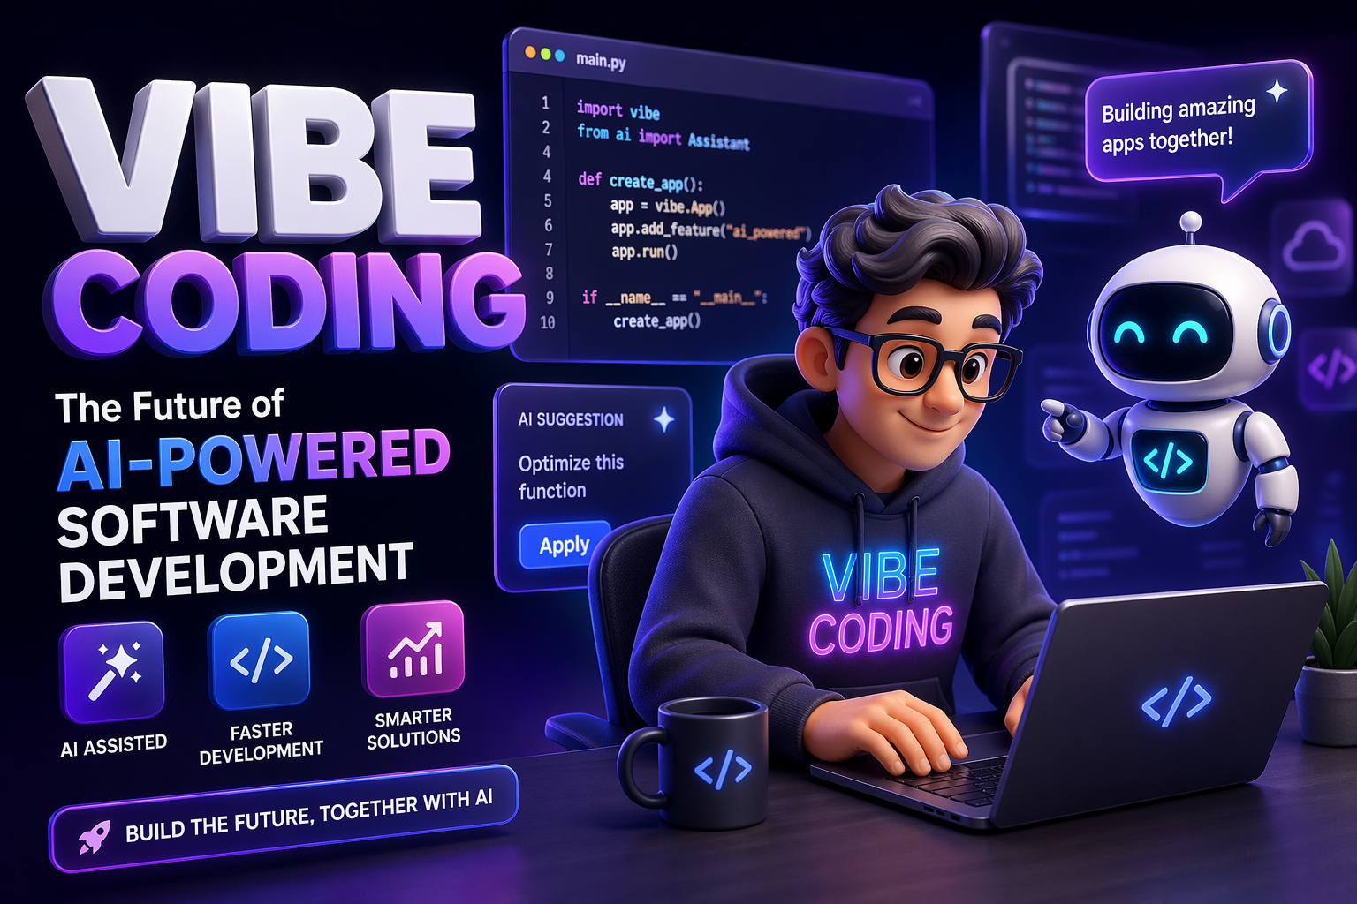

Over 70% of developers now use AI-assisted tools in their workflow and the number is rising fast.” This surge signals a major shift in how software is built. Today, a new paradigm is emerging at the intersection of creativity and automation:Vibe Coding.
Vibe Coding is redefining software development by blending human intuition with artificial intelligence. Instead of focusing solely on syntax and rigid structures, developers are now guiding AI systems with intent, context, and “vibe”- allowing machines to generate, refine, and optimize code in real time. The result is faster development cycles, reduced manual effort, and a more intuitive way to build digital products.
Key Features of Vibe Coding
- Intent-Driven Development:Developers describe what they want, and AI translates it into functional code.
- Real-Time Code Generation:Instant suggestions, auto-completion, and full-function creation.
- Context Awareness:AI understands project structure, reducing errors and improving consistency.
- Rapid Prototyping:Ideas move from concept to working product in hours instead of weeks.
- Continuous Optimization:AI refactors and improves code quality automatically
Industry leaders likeGitHub and OpenAIhave already accelerated this transformation through tools such as AI code assistants and large language models. These technologies empower developers to move from writing every line of code to orchestrating intelligent systems that do much of the heavy lifting.
“Vibe Coding is not just a trend, it’s a fundamental shift in how we think about programming,” said a senior software strategist. “Developers are no longer just coders; they are becoming creative directors of AI-driven systems.”
Tools Powering the Movement
Leading technology platforms are accelerating Vibe Coding adoption. Solutions from GitHub (like Copilot) and OpenAI are enabling developers to collaborate directly with AI. These tools assist in writing code, debugging issues, generating documentation, and even suggesting architecture improvements- making development faster and more accessible.
Real-World Use Cases of Vibe Coding services
Startups:
Early-stage companies are launching MVPs in record time by leveraging AI to handle repetitive coding tasks.
Enterprise Teams:
Large organizations are using Vibe Coding to modernize legacy systems and accelerate digital transformation initiatives.
Freelancers & Creators:
Independent developers are building full-stack applications without large teams, reducing costs and increasing output.
Product Teams:
Rapid experimentation and A/B testing are becoming easier with AI-generated prototypes.
Early adopters report significant productivity gains, with some teams reducing development time by up to 50%. Beyond efficiency, Vibe Coding also lowers barriers to entry, enabling non-traditional developers and startups to bring ideas to life without deep technical expertise.
However, experts emphasize that human oversight remains critical. While AI can generate powerful solutions, developers must ensure accuracy, security, and ethical implementation. Vibe Coding works best as a collaboration where human creativity and machine intelligence amplify each other.
As businesses race to innovate in an increasingly competitive digital landscape, Vibe Coding is quickly becoming a strategic advantage. From startups to enterprises, organizations are leveraging AI-powered workflows to accelerate product development and stay ahead of the curve.
Discover how Vibe Coding can transform your development process. Join the movement shaping the future of software- explore AI-powered tools, experiment with new workflows, and start building smarter today.
For media inquiries, partnerships, or early access opportunities, contact:
Krishna Padam IT Solution
Email Address-
info@kpis.in
Website URL-
https://www.kpis.in/

About: Krishna Padam IT Solution
Established in 2015, Krishna Padam IT Solution merges innovation with creativity, delivering advanced technology solutions that empower businesses. The company specializes in IoT, AI, mobile games, software, web, and app development, serving clients that seek scalable and user-friendly digital products. Its game development work engages audiences worldwide, while its IoT systems and AI integrations support improved efficiency, decision-making, and predictive analytics. By translating visionary ideas into practical solutions, Krishna Padam IT Solution helps organizations navigate and benefit from ongoing digital transformation.

Newsroom
View the full press release including more photos and videos in our Newsroom.
View the full press release
View all previous press releases

Contact information
Name: Krishna Padam IT Solution
Email: info@kpis.in
Phone number: +916350359218

